Infant Incubator Simulator Summary:

The realm of cybersecurity is vast and diverse, touching various facets of our daily lives. Among these, one of the most critical applications is in the domain of healthcare, particularly in life-saving devices like the Infant Incubator. The Infant Incubator Simulator is a unique blend of this real-world application with cybersecurity, offering a hands-on experience for understanding potential threats and vulnerabilities.

At its core, the simulator is designed around an infant incubator, a cyber-physical system meticulously crafted to simulate a controlled, nurturing environment for newborns, particularly preterm infants who require additional care. This environment ensures the baby's vital organs develop safely, outside the mother's womb.

Diving deeper into the mechanics, the simulator leverages a fundamental heat transfer model. This model comprises three primary components: the surrounding room, the incubator chamber, and the infant. Each plays a pivotal role in maintaining the required conditions. For instance, while the room's temperature is maintained at a constant, both the chamber and the infant have dynamic temperatures. The chamber, acting as a protective shield, regulates its temperature based on external factors and the infant's needs. The infant, on the other hand, isn't just a passive entity. Its metabolism acts as an internal heat source, continuously influencing the chamber's environment.

The process of heat transfer isn't instantaneous. It adheres to specific rates, which can be influenced by various factors such as the medium of transfer (conduction, convection, or radiation) and environmental conditions. The simulator is equipped with distinct heat transfer constants for varied materials. For example, human skin and Plexiglass, the primary material of the chamber, have their unique constants ensuring accurate simulation.

The simulator's workflow is systematic, operating in synchronized steps. In each iteration, it evaluates the temperature differentials between the room, chamber, and infant. It then computes the energy gained or lost by the infant and chamber, subsequently updating their energy content and temperature.

One of the standout features of this simulator is its multi-threaded architecture. Each component, whether it's the chamber's heater or the thermometers monitoring temperatures, operates in its individual thread. This multi-threaded design not only mimics real-world operations but also introduces advanced challenges such as real-time constraints, race conditions, and potential system faults.

Furthermore, the simulator is equipped to handle specific events like opening the chamber, introducing an infant, or removing one. Each of these actions has its implications on the temperature and energy dynamics within the system.

In conclusion, the Infant Incubator Simulator isn't just a technical tool; it's an educational bridge between theoretical cybersecurity concepts and their tangible real-world applications. It accentuates the importance of security in life-critical systems and offers a platform to explore, understand, and mitigate potential threats in such systems.

Classes, Methods, and Properties in SampleClient.py:

1. SimpleClient Class:

* Properties:
  + fig: Figure for plotting
  + ax: Axis for plotting
  + lastTime: Last recorded time
  + times: Array storing time values
  + infTemps: Array storing infant temperatures
  + incTemps: Array storing incubator temperatures
  + infLn: Line object for infant temperature plot
  + incLn: Line object for incubator temperature plot
  + infTherm: Thermometer for infant
  + incTherm: Thermometer for incubator
  + ani: Animation object for updating infant temperature
  + ani2: Animation object for updating incubator temperature
* Methods:
  + __init__(self, therm1, therm2): Initializes the SimpleClient with two thermometers.
  + updateTime(self): Updates the time for plotting.
  + updateInfTemp(self, frame): Updates the infant's temperature.
  + updateIncTemp(self, frame): Updates the incubator's temperature.

Outside the class, the file creates instances of Human, SmartThermometer, Incubator, SmartHeater, and Simulator from the infinc module. The temperatures of the infant and incubator are visualized using the SimpleClient class, and the data is plotted using matplotlib

2. Global Variables and Execution:

* Variables:
  + UPDATE_PERIOD: Period for updates (0.05 seconds)
  + SIMULATION_STEP: Step size for the simulation (0.1 seconds)
* Instances:
  + bob: A human (infant) instance
  + bobThermo: A thermometer instance for bob
  + inc: An incubator instance
  + incThermo: A thermometer instance for inc
  + incHeater: A heater instance for inc
  + sim: A simulator instance for the infant incubator system
  + sc: A simple client instance for visualization
* The temperatures are plotted using matplotlib.

Classes, Methods, and Properties in SampleNetworkClient.py:

1. SimpleNetworkClient Class:

* Properties:
  + fig: Figure for plotting.
  + ax: Axis for plotting.
  + lastTime: Last recorded time.
  + times: Array storing time values.
  + infTemps: Array storing infant temperatures.
  + incTemps: Array storing incubator temperatures.
  + infLn: Line object for infant temperature plot.
  + incLn: Line object for incubator temperature plot.
  + infPort: Network port for infant thermometer.
  + incPort: Network port for incubator thermometer.
  + infToken: Authentication token for infant thermometer.
  + incToken: Authentication token for incubator thermometer.
  + ani: Animation object for updating infant temperature.
  + ani2: Animation object for updating incubator temperature.
* Methods:
  + __init__(self, port1, port2): Initializes the SimpleNetworkClient with two network ports.
  + updateTime(self): Updates the time for plotting.
  + getTemperatureFromPort(self, p, tok): Fetches temperature from a given network port using a token.
  + authenticate(self, p, pw): Authenticates and returns a token for a given port using a password.
  + updateInfTemp(self, frame): Updates the infant's temperature using network communication.
  + updateIncTemp(self, frame): Updates the incubator's temperature using network communication.

Outside the class, the file creates an instance of SimpleNetworkClient for visualization and plots the data using matplotlib.

2. Global Variables and Execution:

* Instances:
  + snc: A simple network client instance for visualization.
* The temperatures are plotted using matplotlib.

### Classes, Methods, and Properties in SampleNetworkServer.py:

#### 1. SmartNetworkThermometer Class:

**Properties**:

* source: Source for temperature data.
* updatePeriod: Period for temperature updates.
* curTemperature: Current temperature.
* tokens: List of authentication tokens.
* serverSocket: Server socket for network communication.
* deg: Unit of temperature (K, C, or F).

**Methods**:

* __init__(self, source, updatePeriod, port): Initializes the SmartNetworkThermometer with a source, update period, and port.
* setSource(self, source): Sets the temperature source.
* setUpdatePeriod(self, updatePeriod): Sets the update period.
* setDegreeUnit(self, s): Sets the temperature unit.
* updateTemperature(self): Updates the current temperature.
* getTemperature(self): Returns the current temperature in the desired unit.
* processCommands(self, msg, addr): Processes received network commands and responds accordingly.
* run(self): The main loop for the thread, processing commands and updating the temperature.

#### 2. SimpleClient Class:

**Properties**:

* fig: Figure for plotting.
* ax: Axis for plotting.
* lastTime: Last recorded time.
* times: Array storing time values.
* infTemps: Array storing infant temperatures.
* incTemps: Array storing incubator temperatures.
* infLn: Line object for the infant temperature plot.
* incLn: Line object for the incubator temperature plot.
* infTherm: Thermometer for the infant.
* incTherm: Thermometer for the incubator.

**Methods**:

* __init__(self, therm1, therm2): Initializes the SimpleClient with two thermometers.
* updateTime(self): Updates the time for plotting.
* updateInfTemp(self, frame): Updates the infant's temperature.
* updateIncTemp(self, frame): Updates the incubator's temperature.

#### 3. Global Variables and Execution:

**Variables**:

* UPDATE_PERIOD: Period for updates (0.05 seconds).
* SIMULATION_STEP: Step size for the simulation (0.1 seconds).

**Instances**:

* bob: An instance of a human (infant).
* bobThermo: A thermometer instance for the infant.
* inc: An incubator instance.
* incThermo: A thermometer instance for the incubator.
* incHeater: A heater instance for the incubator.
* sim: A simulator instance for the infant incubator system.
* sc: A simple client instance for visualization.

The temperatures are plotted using matplotlib.

### Classes, Methods, and Properties in infinc.py:

#### 1. SimpleThermometer Class:

**Properties**:

* source: Source for temperature data.

**Methods**:

* __init__(self, source): Initializes the SimpleThermometer with a source.
* setSource(self, source): Sets the temperature source.
* getTemperature(self): Returns the temperature from the source.

#### 2. SimpleHeatGenerator Class:

**Properties**:

* power: Power output in watts.
* setTemperature: Desired set temperature.
* thermometer: Associated thermometer.

**Methods**:

* __init__(self, powerOutput, setTemperature, thermometer): Initializes the heater with power output, set temperature, and thermometer.
* setThermometer(self, thermo): Sets the thermometer.
* getOutput(self): Returns the heater's output in watts based on the current temperature.

#### 3. Human Class (Partial):

**Properties**:

* (Various properties related to the human, like mass, length, temperature, etc.)

**Methods**:

* (Various methods related to simulating human temperature changes.)

#### 4. Incubator Class (Partial):

**Properties**:

* (Various properties related to the incubator, like width, depth, height, temperature, etc.)

**Methods**:

* (Various methods related to simulating the incubator's interactions with the environment.)

#### 5. Simulator Class:

**Properties**:

* infant: The human (infant) being simulated.
* incubator: The incubator being simulated.
* roomTemperature: Ambient room temperature.
* iteration: Current simulation iteration.
* timeStep: Time step for the simulation.
* sleepTime: Sleep time between simulation steps.

**Methods**:

* __init__(self, infant, incubator, roomTemp, timeStep, sleepTime): Initializes the simulator with an infant, incubator, room temperature, time step, and sleep time.
* run(self): Main loop for the simulation, updating the infant and incubator based on interactions.

Architecture:

1. Environment:

- Description: This is the overarching environment in which the incubator system resides.

- Components:

- Room:

- Maintains a steady ambient temperature.

- Houses the infant incubator system.

2. Incubator System:

- Description: The main system designed to provide an optimal environment for the infant.

- Components:

- Chamber:

- The primary unit where the infant is placed.

- Interacts with both the heater and thermometers.

- Heater:

- Regulates and maintains the desired temperature inside the chamber.

- Can be controlled remotely for adjustments.

- Incubator Thermometer:

- Continuously monitors the temperature inside the chamber.

- Sends data to the simulator and potentially to the network for remote monitoring.

3. Infant:

- Description: The end beneficiary of the incubator system.

- Components:

- Thermometer:

- Continuously monitors the infant's temperature.

- Sends data to the simulator and potentially to the network for remote monitoring.

4. Simulator:

- Description: A software component that simulates the real-world interactions of the system.

- Functions:

- Controls the flow of the simulation, updating temperatures and energy transfers.

- Interacts with all components to ensure realistic behavior.

5. Network Components:

- Description: Allows for remote monitoring and control of the incubator system.

- Components:

- Network Server:

- Handles incoming requests.

- Fetches and provides temperature data or system controls as requested.

- Network Client:

- Initiates requests to the server.

- Visualizes or displays the data fetched from the server.

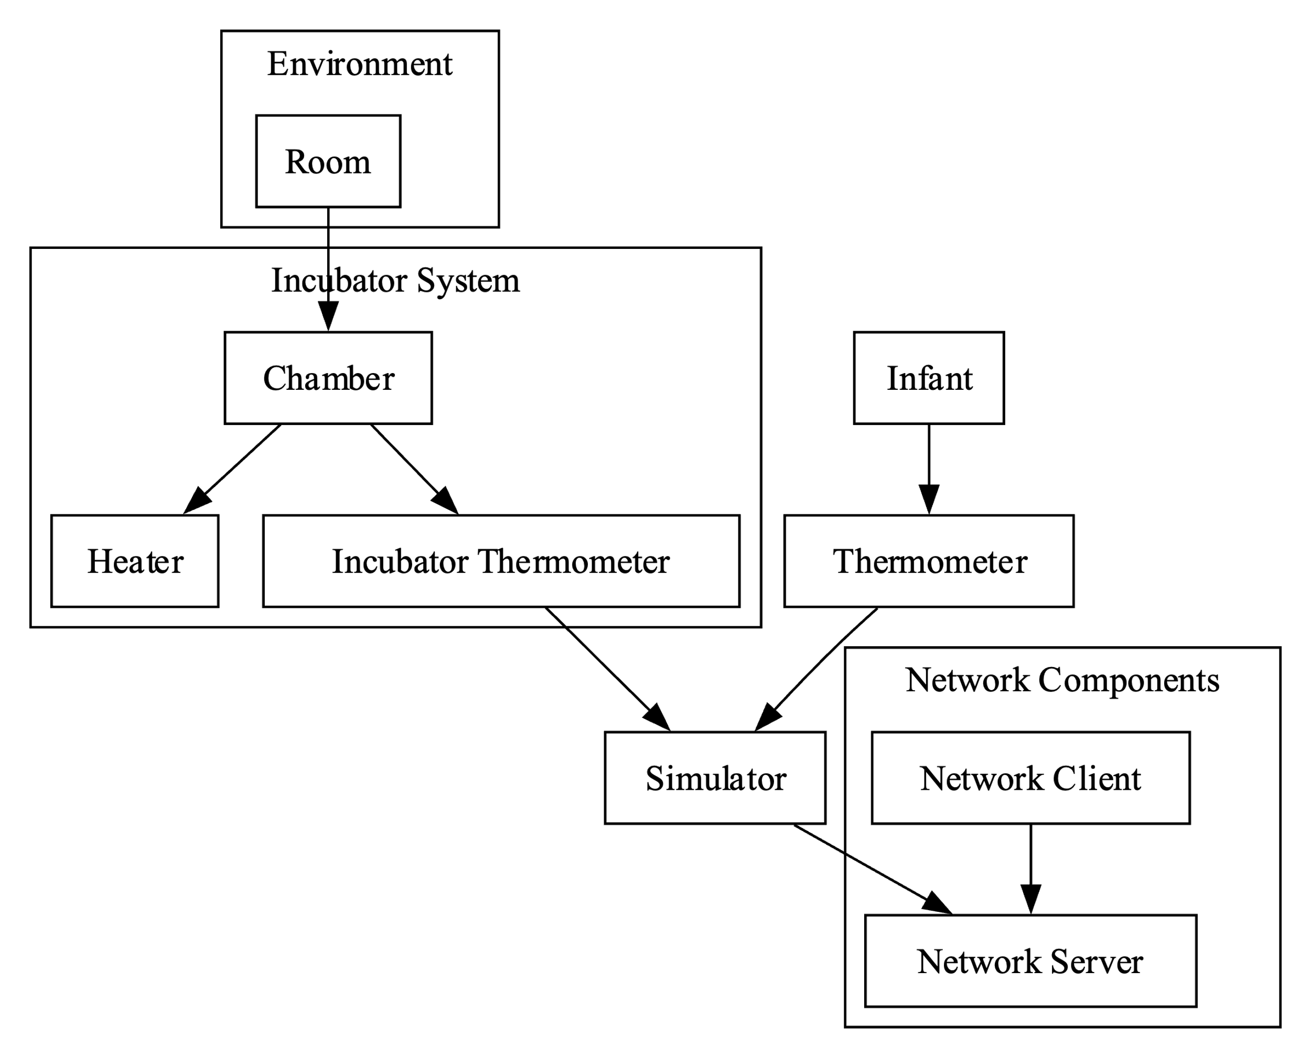

5. Explanation of Violations:

a. Password is Hardcoded (SampleNetworkClient.py):

Violation of Security Requirements:

- Authentication: Hardcoding a password in the code means that anyone who has access to the source code or can reverse-engineer the client application will know the password. This compromises the principle of ensuring only authorized users can access and control the incubator remotely.

- Secure Defaults: A hardcoded password is not a secure default. It means every instance of this client uses the same password, making it easy for attackers to guess.

Exploitation:

- An attacker can easily extract the hardcoded password from the source code or by reverse-engineering the application. Once the password is known, the attacker can authenticate with the server, potentially gaining unauthorized access to control or monitor the incubator.

b. Token List has the potential to continuously grow (SampleNetworkServer.py):

Violation of Security Requirements:

- Availability: If the token list can grow indefinitely, it can consume all available memory resources, leading to a Denial of Service (DoS) where the server becomes unresponsive.

- Data Integrity: Over time, old tokens that should have been invalidated might still be usable if not properly managed, risking unauthorized access.

Exploitation:

- Attackers can repeatedly authenticate to the server, causing the token list to grow. If not properly managed, this can lead to resource exhaustion and potential DoS.

- If token cleanup is not implemented, an attacker might be able to reuse old tokens for unauthorized access.

c. Plaintext authentication token and authentication (SampleNetworkClient.py):

Violation of Security Requirements:

- Data Confidentiality: Sending authentication tokens and credentials in plaintext means anyone intercepting the network traffic can read and potentially misuse them.

- Authentication: Plaintext authentication can be intercepted and replayed by attackers to gain unauthorized access.

Exploitation:

- Attackers can use packet sniffing tools to capture network traffic and extract plaintext tokens and credentials. Once obtained, they can use these details to impersonate a legitimate user or device, leading to unauthorized access or control of the incubator.

Recommendations:

To mitigate these vulnerabilities:

- Avoid hardcoding passwords. Instead, use secure methods like environment variables or secure configuration files.

- Implement token management on the server side to periodically clean up old or expired tokens.

- Use secure communication protocols (e.g., HTTPS) to encrypt data transmission. Implement proper authentication and authorization mechanisms that don't rely solely on plaintext tokens.